 | OLX Resale  Technical Design Document  1.0
 | Prepared By / Last Updated By | Reviewed By | Approved By
Name | Abiranjeetha A R | Srinithi I | Suganthi S | Praveen Christhu Raj
Role | Team Member | Team Member | Team Member | Team Member
Signature
Date | 27/05/2019 | 27/05/2019 | 27/05/2019 | 27/05/2019

Table of Contents

1.0 Introduction 4
1.1 Purpose of this document 4
1.2 Scope 4
1.3 Intended Audience 4
1.4 Definition & Acronyms 4
2.0 Conventions and Standards Followed 5
3.0 Assumptions, Dependencies and Risks 5
3.1 Assumptions: 5
3.2 Dependencies: 5
4.0 Schematic Diagram 5
5.0 Use Case Realization 6
5.1.1 User Signup 6
a. Functional Requirement 7
b. UI Validations 7
c. UI Controls 8
d. UI Methods Definition 9
e. UI Design 9
5.1.2 User Login 10
a. Functional Requirement 10
b. UI Validations 10
c. UI Controls 11
d. UI Methods Definition 11
e. UI Design 11
5.1.3 Sell Product 12
a. Functional Requirement 12
b. UI Validations 12
c. UI Controls 13
d. UI Methods Definition 13
e. UI Design 14
5.1.4 Product description 15
a. Functional Requirement 15
b. UI Validations 15
c. UI Controls 16
d. UI Methods Definition 16
e. UI Design 17
5.1.5 User cart 18
a. Functional Requirement 18
b. UI Validations 18
c. UI Controls 18
d. UI Methods Definition 19
e. UI Design 19
5.1.6 User ads 20
a. Functional Requirement 20
b. UI Controls 20
c. UI Methods Definition 21
d. UI Design 21
6.0 Database Design 23
6.1 Data Model 23
The following is a schematic view of the database design 23
6.2 Tables Structure 24
6.2.1 List of tables: 24
7.0 Change Log 26

Introduction

Purpose of this document
The purpose of the detail design document is to define the detailed design for all the components of OLX Resale system that are specified in the Business Requirement/Use case document. All the low level components, interfaces and integrations are detailed out in this document.

Scope
This sub-section shall state the scope of this detailed design document
• Allows the user resell the product online.
• Allows the user to buy product online.

Intended Audience
The intended audience for this document are
- Developers, testers, other associates in the project
- Technical lead, Scrum Master
- Product Owner

Definition & Acronyms
Acronyms | Definitions

Conventions and Standards Followed
The modules under scope needs to adhere to the coding standards and guidelines


Assumptions, Dependencies and Risks

Assumptions:
- Once the application is built the category names and category id are stored into the database manually by admin.
- There will be no concurrent users for the application.
- The item Id and user Id are auto generated.

Dependencies:
- Availability of database design characteristics & access shall be defined by the resource availability throughout each of the sprint

Schematic Diagram
A schematic, or schematic diagram, is a representation of the elements of a system using abstract, graphic symbols rather than realistic pictures. It gives an overview of overall system
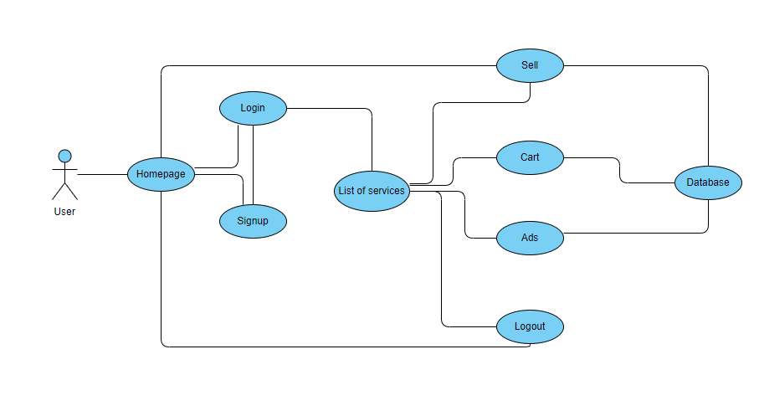
The above pic is only an example and not representational of the OLX Resale

Use Case Realization

User Signup
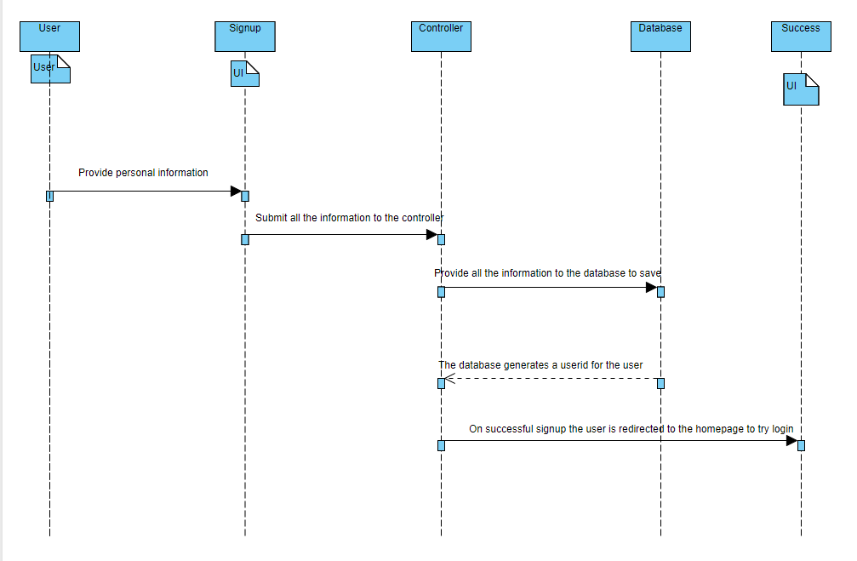

Functional Requirement
. Signup page receives all the user information and stores in the database. All the fields are mandatory.

UI Validations
Please refer to the below requirements for field level validations:

- All fields are mandatory.
- The mobile format must be checked. (For ex.9876543210)
- The password must contain minimum of 6 characters.
- The email Id must be in the valid Id format.
- The first name and last name must be minimum 5 characters and maximum 30 characters.

UI Controls
# | UI Component | Type | Name | Details
1 | First name | Text field | Firstname | To enter firstname
2 | Last name | Text field | Lastname | To enter lastname
3 | Age | Text field | Age | To enter age
4 | Gender | Dropdown | Gender | To select gender
5 | Contact number | Text field | Contactnumber | To enter contact number
6 | Password | Text field | password | To enter password
7 | Email | Text field | email | To enter email
8 | City | Text field | City | To enter city
9 | Sub Location | Text field | Location | To enter sub location
10 | State | Text field | State | To enter state
11 | Country | Text field | Country | To enter country
12 | Pin code | Text field | Pincode | To enter pin code
13 | Street | Text field | Street | To enter street
14 | Signup | Button | Signup | Button to submit user details and signup into the system
15 | Reset | Button | Reset | Button to reset the values entered in the form

UI Methods Definition
Method Name | Parameter | Details
SignButton_Click | object sender, EventArgs e | Allows the user to signup into the system and register the user
ResetButton_Click | object sender, EventArgs e | Clears the details entered by the user.

UI Design
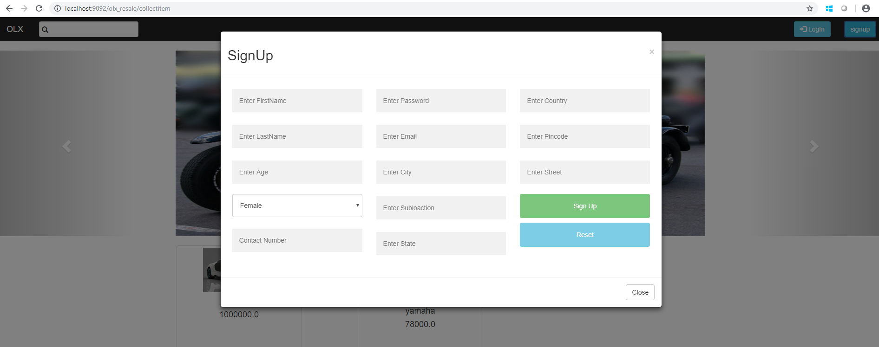

5.1.2 User Login
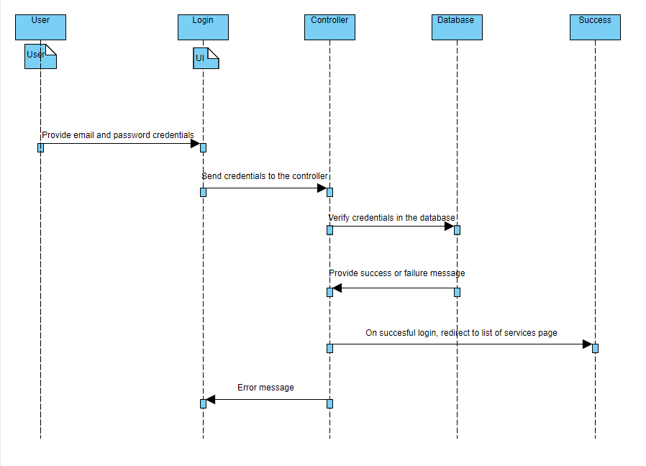

Functional Requirement
. Login page accepts the user credentials and verifies them in the database. All the fields are mandatory.

UI Validations
Please refer to the below requirements for field level validations:

- All fields are mandatory.
- The password must contain minimum of 6 characters.
- The email Id must be in the valid Id format.
- Password and email-Id must match.

UI Controls
# | UI Component | Type | Name | Details
1 | Email | Text field | email | To enter email
2 | Password | Text field | password | To enter password
3 | Login | Button | Login | Button to submit user credentials and login into the system
4 | Reset | Button | Reset | Button to reset the values entered in the form

UI Methods Definition
Method Name | Parameter | Details
LoginButton_Click | object sender, EventArgs e | Allows the user to login into the system
ResetButton_Click | object sender, EventArgs e | Clears the details entered by the user.

UI Design
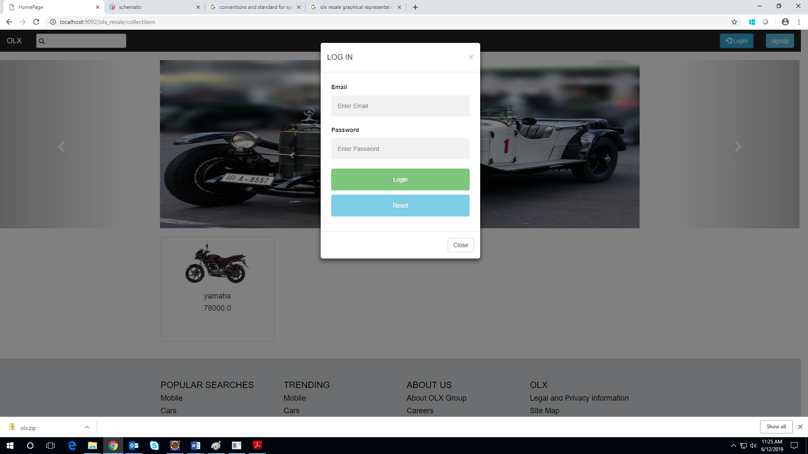

5.1.3 Sell Product
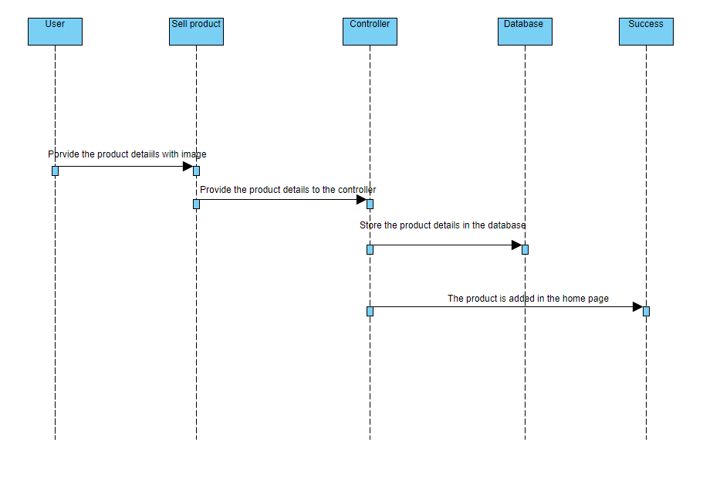

Functional Requirement
. Sell page accepts the details of the product to be sold and stores them in the database. All the fields are mandatory. The product is added in the myads page.

UI Validations
Please refer to the below requirements for field level validations:

- All fields are mandatory.

UI Controls
# | UI Component | Type | Name | Details
1 | Item name | Label | Itemname
2 | Item name | Text field | Itemname | To enter item name
3 | Category | Label | category
4 | Category | Drop down | category | To select category
5 | Price | Label | price
6 | Price | Text field | price | To enter price
7 | Years of usage | Label | yearsofusage
8 | Years of usage | Text field | yearsofusage | To enter years of usage
9 | Quantity | Label | quantity
10 | Quantity | Text field | quantity | To enter quantity
11 | Upload Image | Label | image
12 | Image | File | image | To upload image
13 | Description | Label | description
14 | Description | Text Area | description | To enter description
15 | Submit | Button | Submit | To submit the product details and store in database.

UI Methods Definition
Method Name | Parameter | Details
SubmitButton_Click | object sender, EventArgs e | Allows the user to post the ad to sell their product .

UI Design
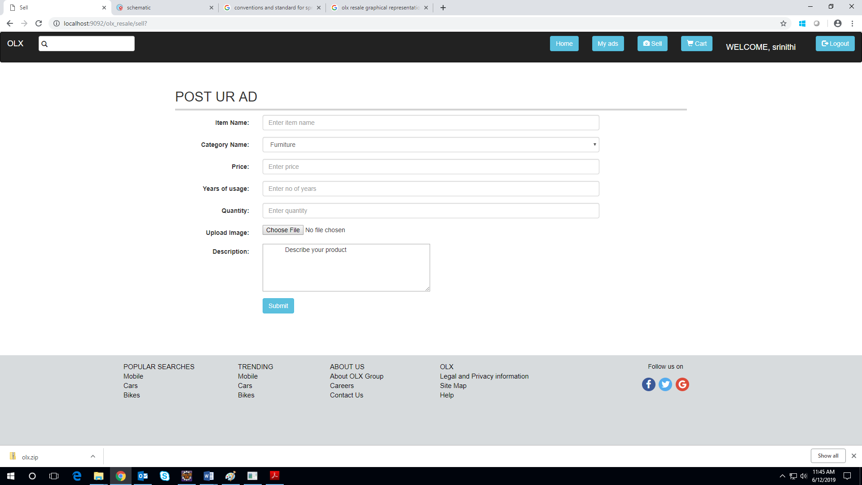

5.1.4 Product description
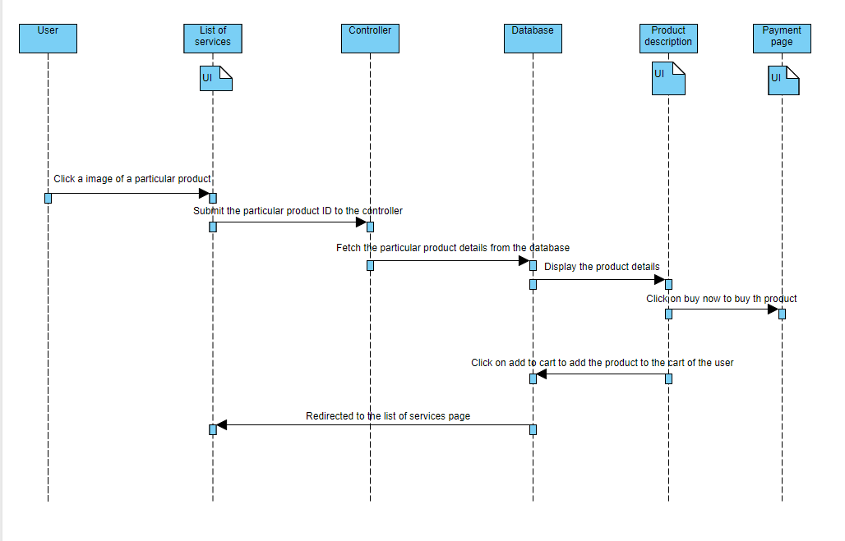

Functional Requirement
. Product description page displays the details of the product by fetching them from the database. From this page the product can be added to the cart or bought.

UI Validations
Please refer to the below requirements for field level validations:

- For buying the product, quantity of the product must be provided.

UI Controls
# | UI Component | Type | Name | Details
1 | Image | Image modal | Image | To display the product image
2 | Product description | Text area | description | To display the product description
3 | Price | Text field | price | To display the product price
4 | Quantity | Text field | Quantity | To specify the quantity
5 | Add to cart | Button | addtocart | To add the product to the cart
6 | Buy now | Button | buynow | To buy the product ,goes to the payment page

UI Methods Definition
Method Name | Parameter | Details
AddtocartButton_Click | object sender, EventArgs e | Allows the user to add the product in their cart
BuynowButton_Click | object sender, EventArgs e | Allows the user to buy the product

UI Design
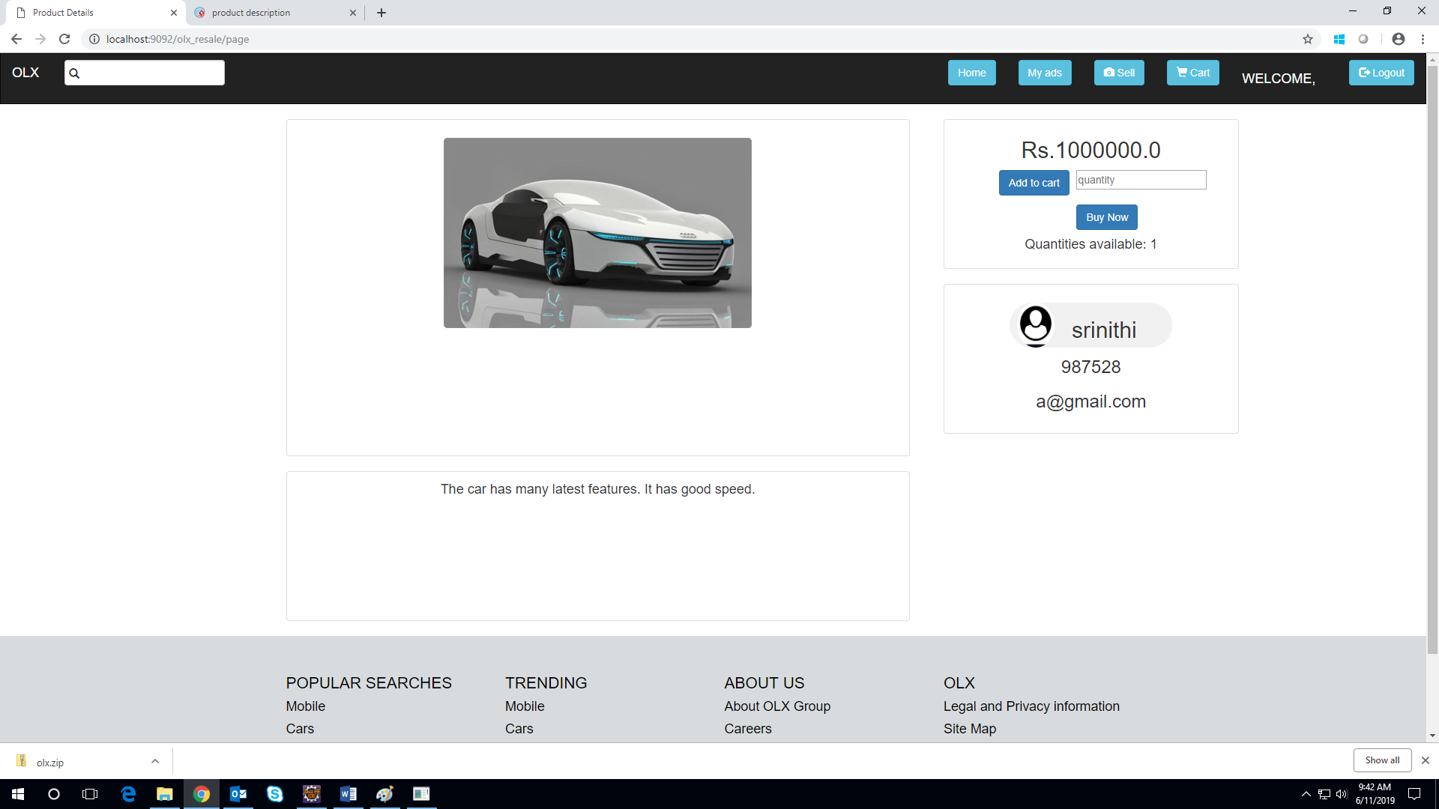

5.1.5 User cart
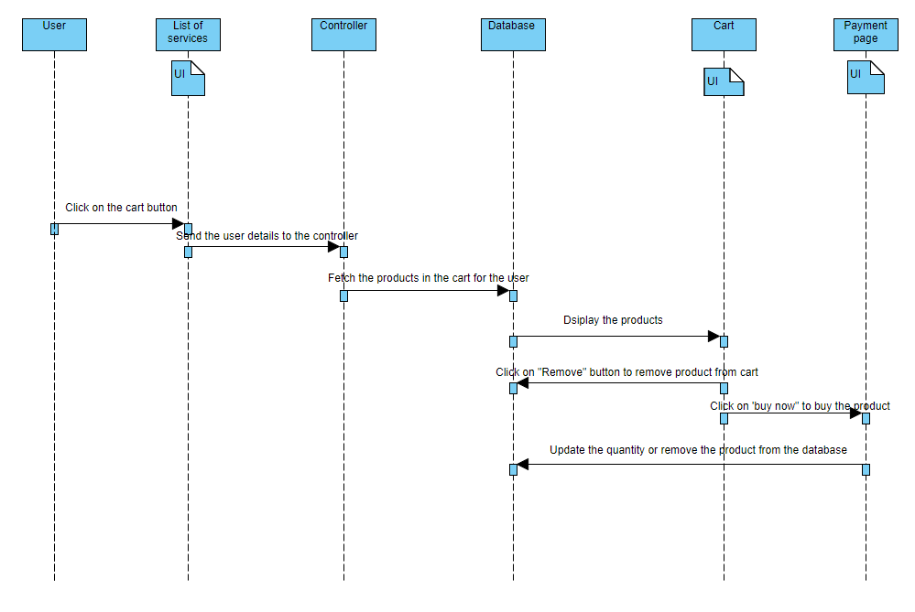

Functional Requirement
. To display the product added in their cart.

UI Validations
Please refer to the below requirements for field level validations:

- For buying the product, quantity of the product must be provided.

UI Controls
# | UI Component | Type | Name | Details
1 | Quantity | Text field | Quantity | To specify the quantity
2 | Buy now | Button | buynow | To buy the product ,goes to the payment page
3 | Remove | Button | Remove | To remove the products added in their cart

UI Methods Definition
Method Name | Parameter | Details
BuynowButton_Click | object sender, EventArgs e | Allows the user to buy the product
RemoveButton_Click | object sender, EventArgs e | Allows the user to remove the product

UI Design
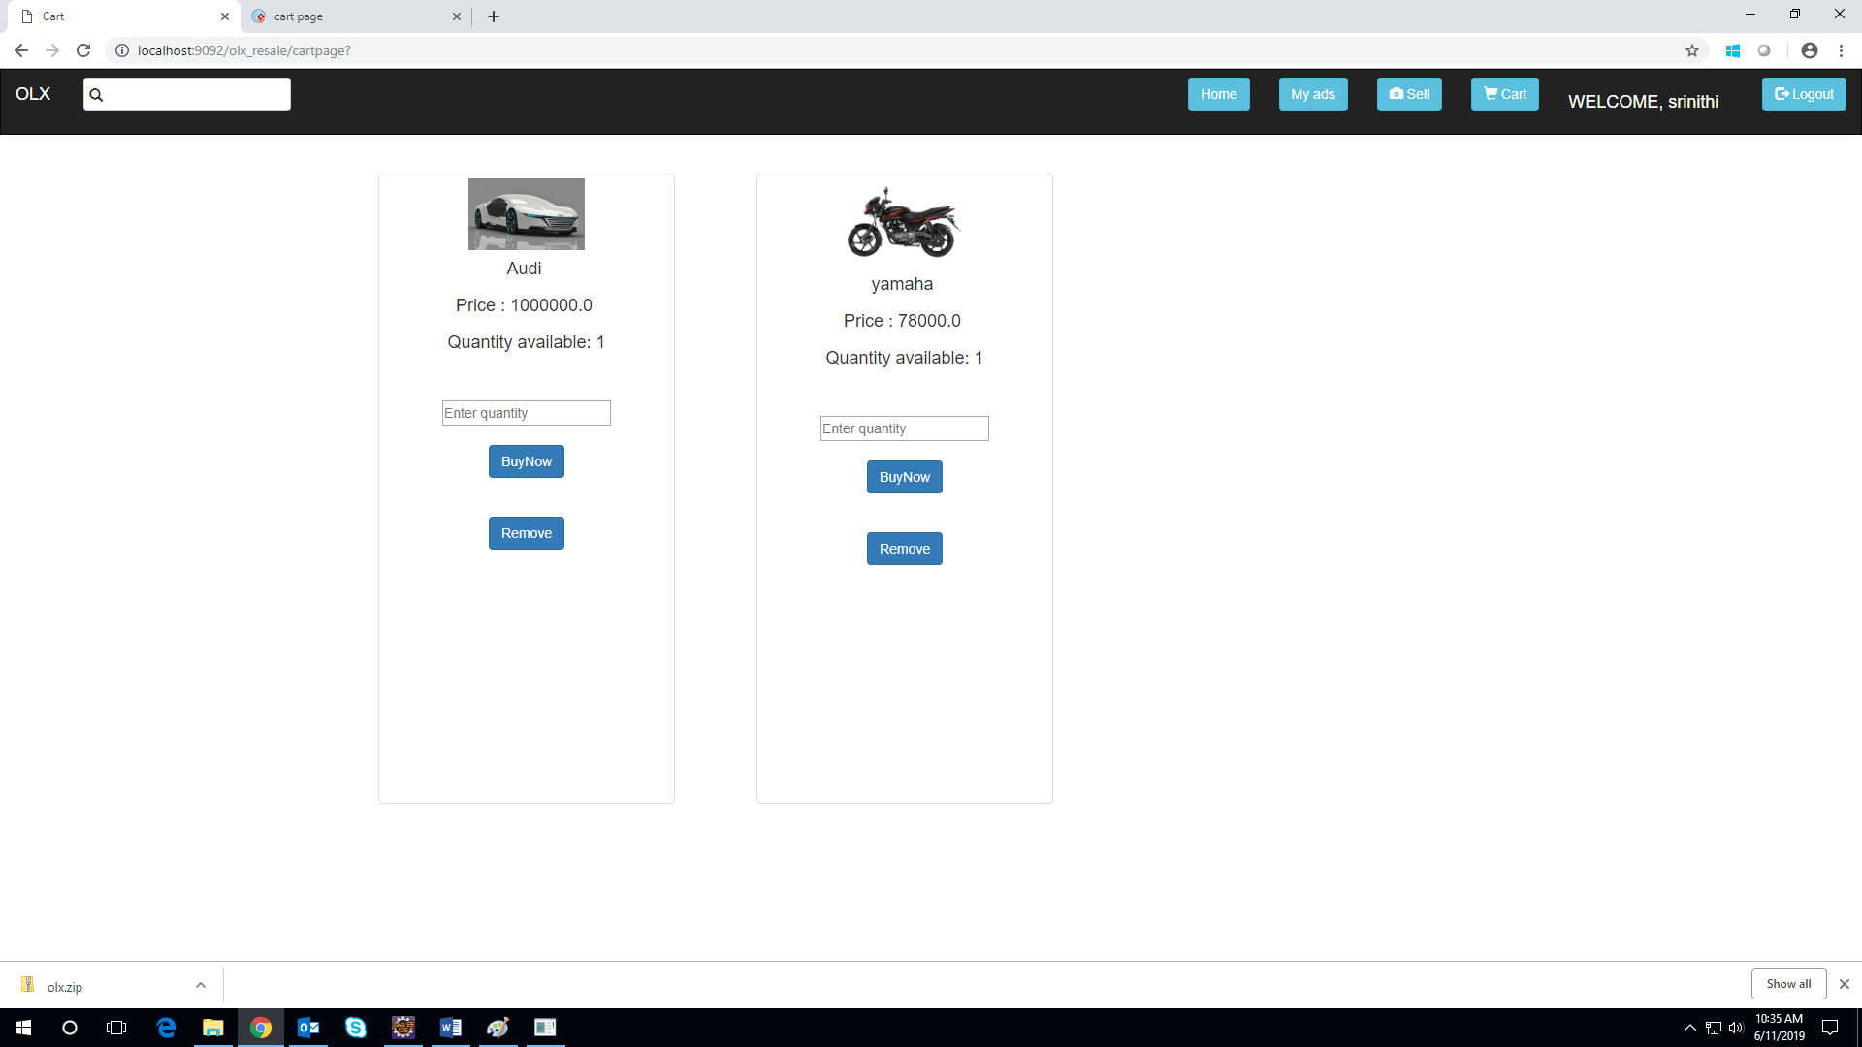

5.1.6 User ads
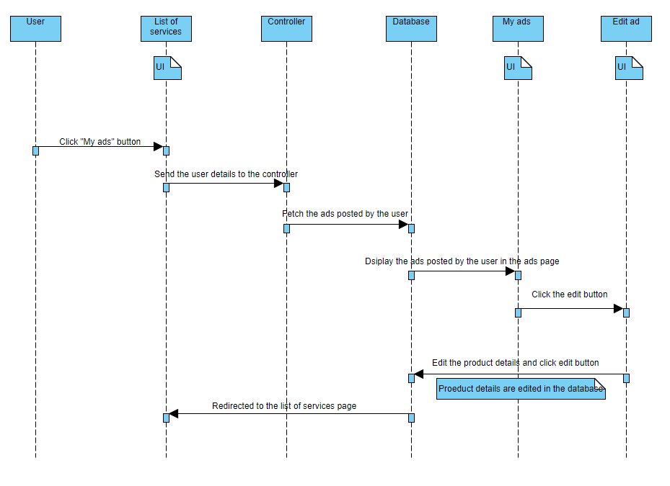

Functional Requirement
. To display the product for the user who posted.

UI Controls
# | UI Component | Type | Name | Details
1 | Remove | Button | Remove | To remove the products added in their cart
2 | Edit | Button | edit | To edit the product details

UI Methods Definition
Method Name | Parameter | Details
EditButton_Click | object sender, EventArgs e | Allows the user to edit the product.
RemoveButton_Click | object sender, EventArgs e | Allows the user to remove the product

UI Design
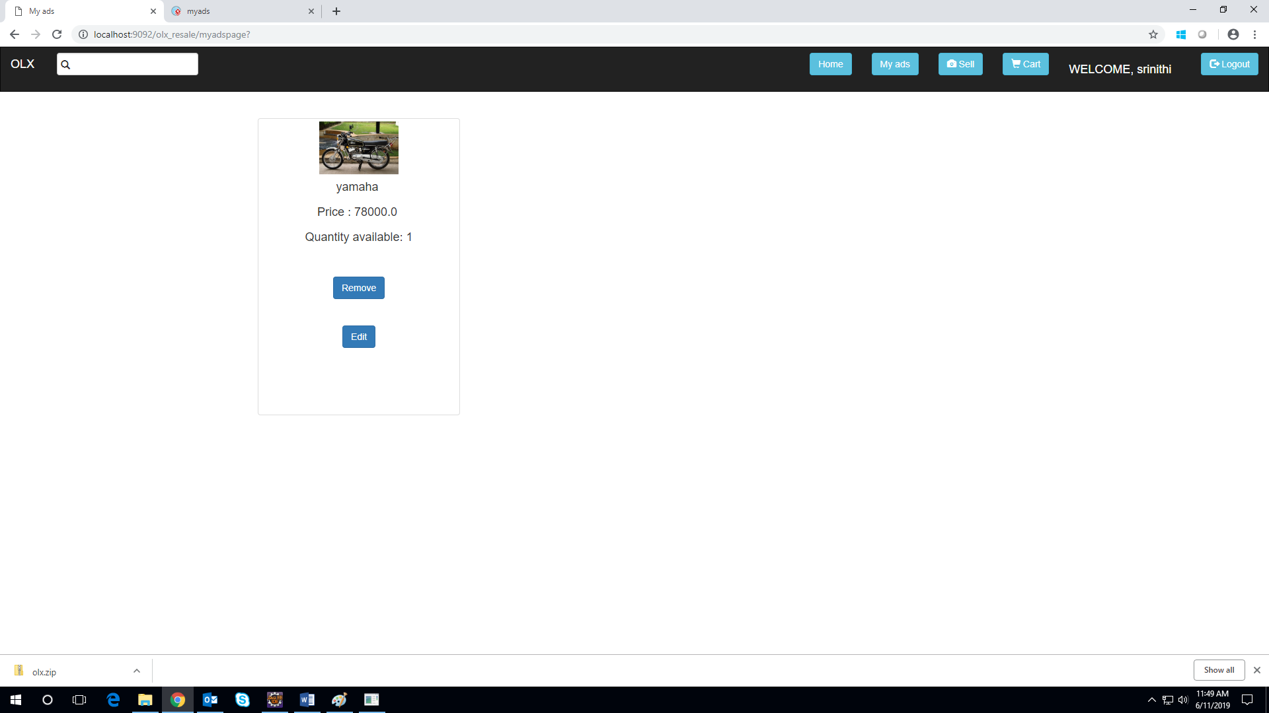

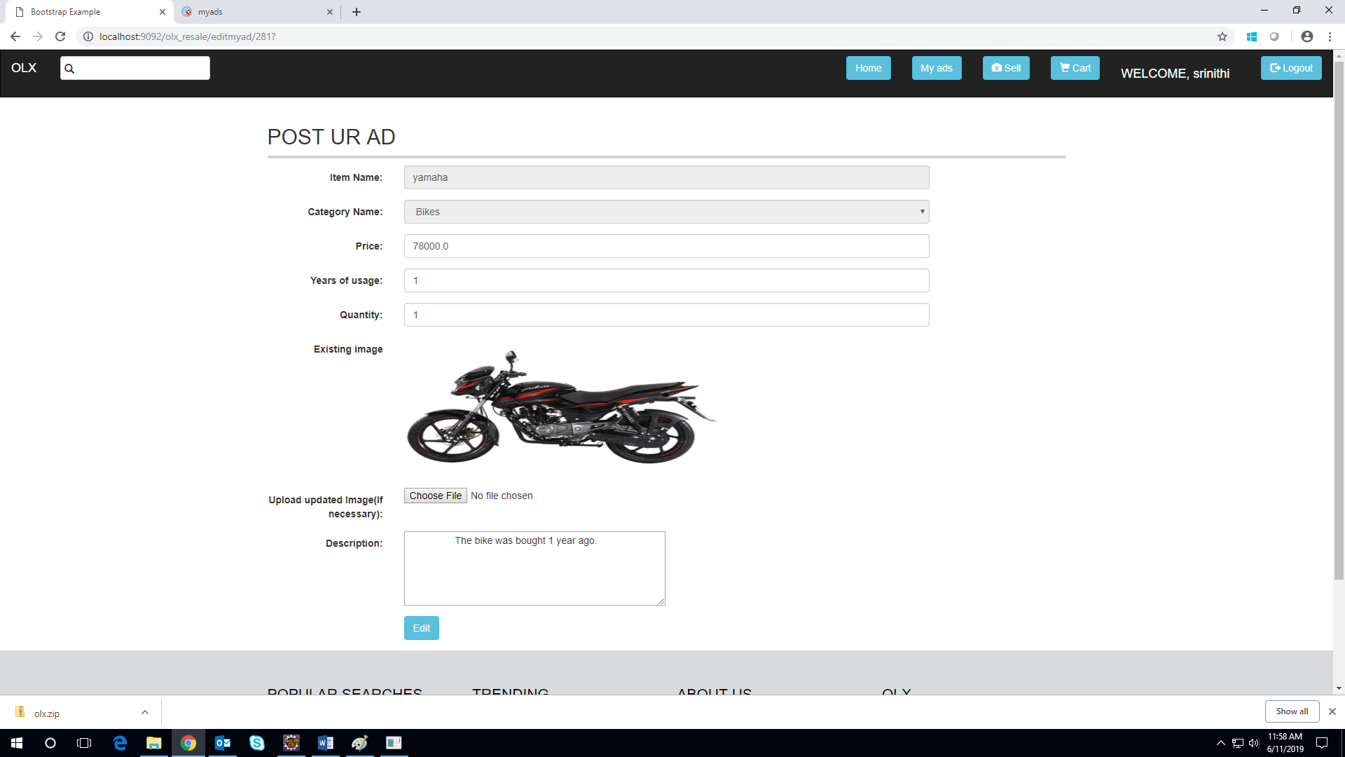

Database Design

Data Model

The following is a schematic view of the database design
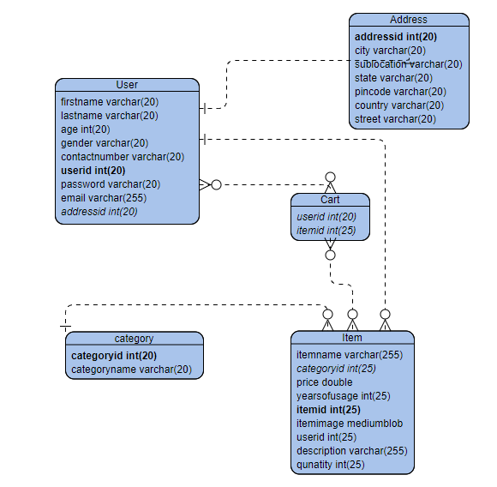

Tables Structure

6.2.1 List of tables:
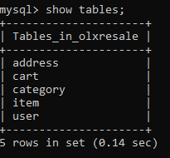

6.2.2 User details:
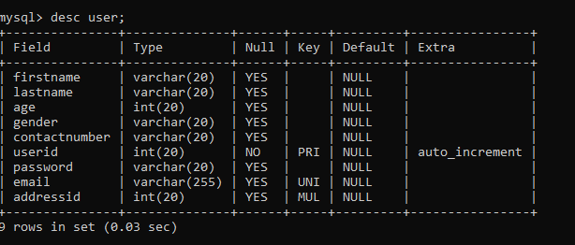
6.2.3 Address details:
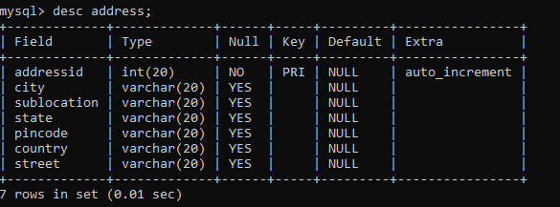
6.2.4 Item details:
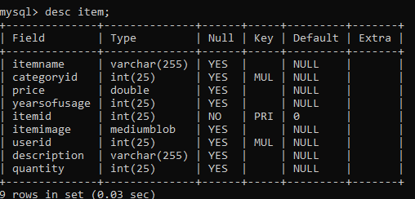

6.2.5 Category details:
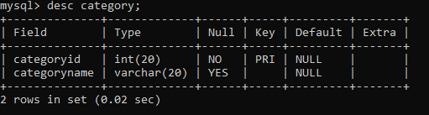
6.2.6 Cart details:
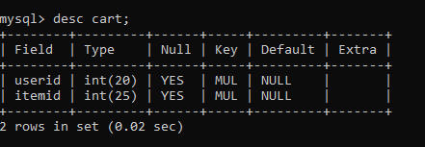

Change Log
Please note that this table needs to be maintained even if a Configuration Management tool is used.
Version Number | Changes made
V1.0 | <First version>
V1.1 | <If the change details are not explicitly documented in the table below, reference should be provided here>
V1.1 | Page no | Changed by | Effective date | Changes effected
V1.2 | <If the change details are not explicitly documented in the table below, reference should be provided here>
V1.2 | Page no | Changed by | Effective date | Changes effected

